EMCH 310 Jacob VAUGHT Homework 2
Due September 13, 2021, by 5: 00pm
- The van travels over the hill described by $y=(\left(-1.5\left({10}^{-3}\right)x^{2}+15\right)ft$. If it has a constant speed of 75ft/s, determine the x and y components of the van’s velocity and acceleration when x=50ft.
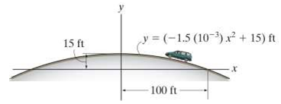
$$y=(-1.5\left({10}^{-3}\right)x^{2}+15$$
This determines the slope of the curve at any point x.
$$f^{'}\left(x\right)=(-3\left({10}^{-3}\right)x$$
Slope at 50$=(-3\left({10}^{-3}\right)*50=-0.150$
Angle = arctan(0.150)=8.53076°
Velocity in x direction= cos(8.53076°)=0.988936353*75=74.17
Velocity in y direction= sin(8.53076°)=0.148340453*75=11.126
Acceleration $f^{''}\left(x\right)=-3*{10}^{-3}\left(\dot{x}\dot{x}+\ddot{x}x\right)→a_{y}=-3*{10}^{-3}\left(V_{x}^{2}+a_{x}*x\right)$
$$a_{y}=\frac{-3}{1000}\left({74.17}^{2}+50*a_{x}\right)$$
Because the van travels at a constant velocity across the arc/hill, acceleration at the tangent is 0.
$$a_{y}*sin\left(\tan\left(-0.15\right)\right){= a}_{x}*\cos\left(\tan\left(-0.15\right)\right)$$
$$a_{x}=2.53252 ft/s^{2}; a_{y}=-16.8834ft/s^{2}$$

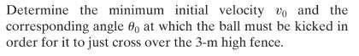
2)
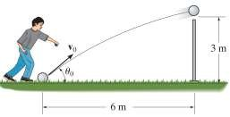
$x0=0m;x=6m$
$$vx=vcos\left(θ\right)$$
$$y0=0m;y=3m;a=-{9.806m}/{s^{2}};vy=vsin(θ)$$
$$6=vcos(θ)t→t=\frac{6}{vcos\left(θ\right)}$$
$$3=v sin\left(θ\right)*t+0.5*-9.806*t^{2}$$
$$3=v sin\left(θ\right)*\frac{6}{vcos\left(θ\right)}+0.5*-9.806*{\left(\frac{6}{vcos\left(θ\right)}\right)}^{2}$$
SIMPLIFY
$$3-\frac{6\sin\left(θ\right)}{\cos\left(θ\right)}=-\frac{176.508}{v^{2}\cos^{2}{(θ)}}$$
$$-3\cos^{2}{θ}+\frac{6\sin{θ}*\cos^{2}{θ}}{\cos{θ}}=\frac{176.508}{v^{2}}=6\sin{θ}*cos{θ}-3\cos^{2}{θ}$$
$$\frac{176.508}{v^{2}}=6\sin{θ}*cos{θ}-3\cos^{2}{θ}→\frac{176.508}{3sin⁡(2θ)-3\cos^{2}{θ}}=v^{2}$$
$$\frac{58.836}{sin⁡(2θ)-\cos^{2}{θ}}=v^{2}→\sqrt{\frac{58.836}{\sin\left(2θ\right)-\cos^{2}{θ}}}=v$$
To determine the optimal angle, take the derivative of the equation and set equal to 0
$$\frac{d}{dθ}\left(\sin\left(2θ\right)-\cos^{2}{θ}\right)=0→2\cos\left(2θ\right)+\sin\left(2θ\right)=0$$
$$θ=58.28253°$$
$$\sqrt{\frac{58.836}{\sin\left(2*58.28253\right)-\cos^{2}{58.28253}}}=v=9.75698 m/s$$
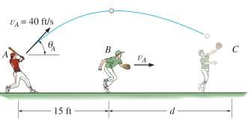
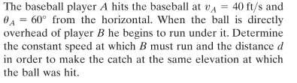
3)

Known variables:
Vx0=cos(60)*40
X0=0
Ax=0

Y0=0
Y=0
Vy0=sin(60)*40
Ay=-32.2

Y=y0+vy0*t+0.5*ay*t^2
$$0=0+sin(60)*40*t+0.5*-32.2*t^{2}$$
$$T=\frac{(sin{60}*40)}{16.1}=2.1516$$
$$x=0+\cos\left(60\right)*40*2.1516=43.032=TOTAL distance$$
$$43.032-15=28.032ft$$
$$VAx=VB=\cos\left(60\right)*40=20ft/s$$

